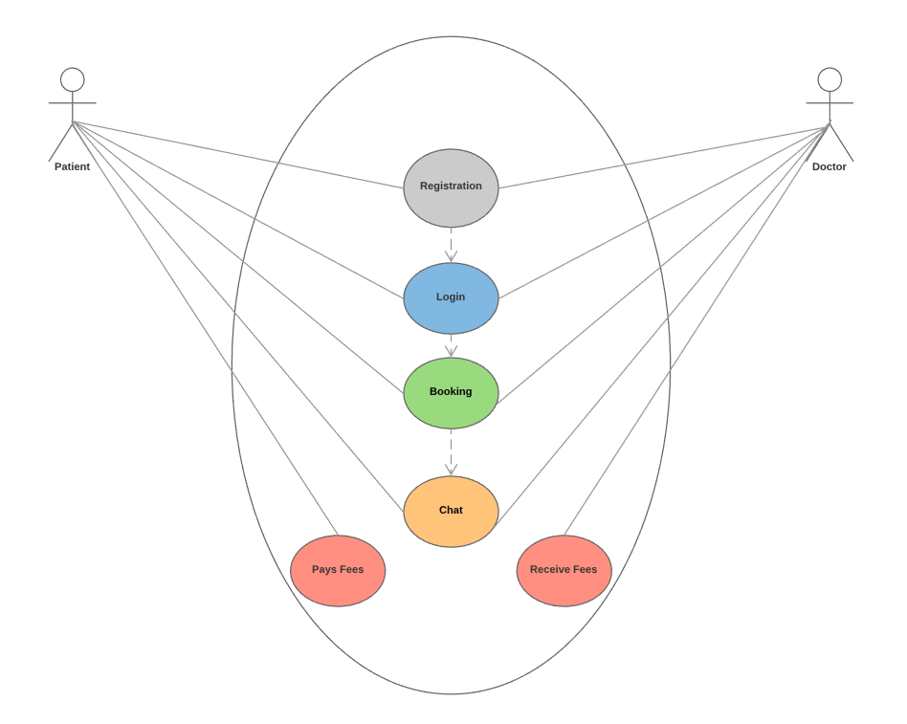

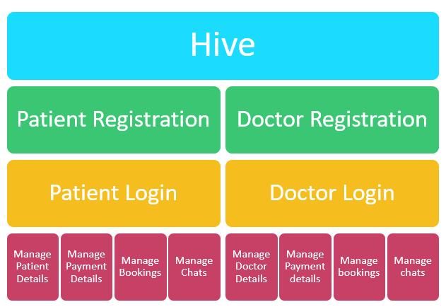

# Manage Patient Details

1. Patient
   1. Name
      1. First name
      2. Last name
   2. Address
      1. Street number
      2. Street name
      3. Suburb
      4. Postcode
      5. Country
   3. Date of Birth
      1. Day
      2. Month
      3. Year
   4. Contact details
      1. Phone number
      2. Email
   5. Login details
      1. Username
      2. Password
   6. Booking Options
      1. Booking ID
      2. Booking type
         1. Standard
         2. Long
         3. Special
      3. Booking details
         1. Date
            1. Day month year
         2. time
   7. Payment Options
      1. Credit card
         1. Credit card type
         2. Name on Credit Card
         3. Number on Credit card
         4. Expiry date
         5. CCV
      2. Direct Debit
         1. BSB
         2. Account name
         3. Account number

# Manage Doctor Details

1. Doctor
   1. Name
      1. First name
      2. Last name
   2. Clinic Address
      1. Clinic Name
      2. Street number
      3. Street name
      4. Suburb
      5. Postcode
      6. Country
   3. Date of Birth
      1. Day
      2. Month
      3. Year
   4. Contact details
      1. Phone number
      2. Email
   5. Login details
      1. Username
      2. Password
   6. Booking Options
      1. Booking ID
      2. Booking type
         1. Standard
         2. Long
         3. Special
      3. Booking details
         1. Date
            1. Day month year
         2. time
   7. Billing Options
      1. Payments OUT
         1. Credit card
            1. Credit card type
            2. Name on Credit Card
            3. Number on Credit card
            4. Expiry date
            5. CCV
      2. Payments IN
         1. BSB
         2. Account name
         3. Account number